**R.E.**

**at**



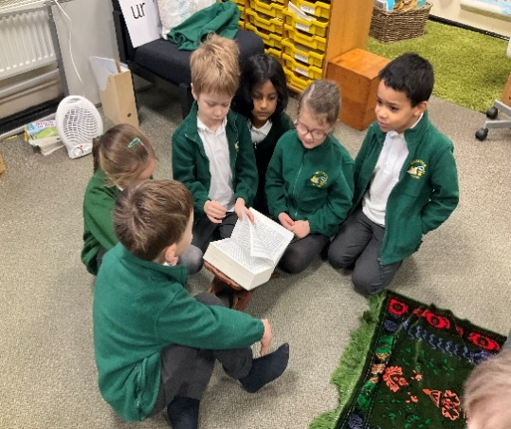

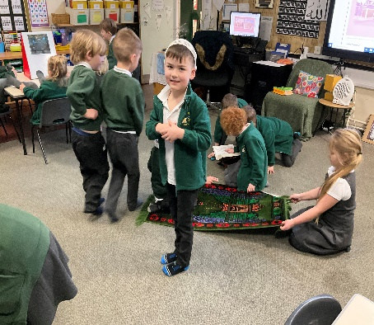

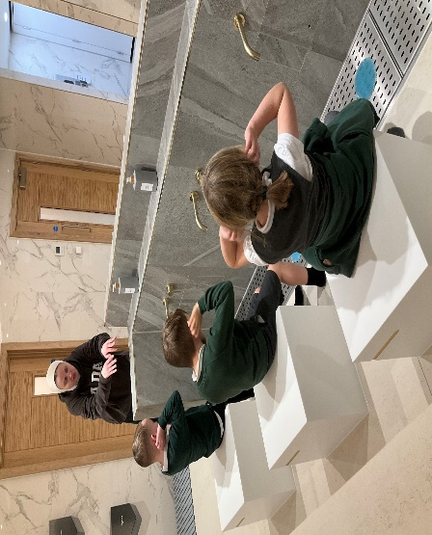

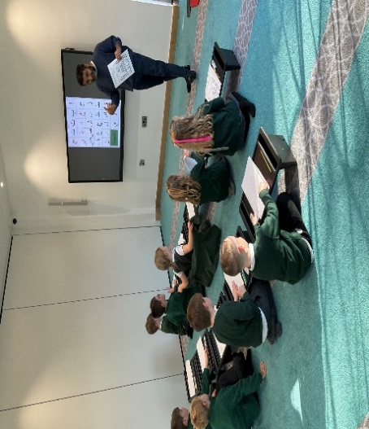

It’s all to do with the ‘Big Ideas’ and finding out about the wider world.

In Year 1 & 2, our children engage in R.E. lessons for an hour each week. They have the opportunity to engage in systematic enquiry so that they can develop the understanding and skills needed to appreciate different religions and beliefs. We follow the Stockport agreed scheme of work. Lessons are reviewed and evaluated regularly to ensure provision is relevant up to date and of high quality.

Our curriculum and approach

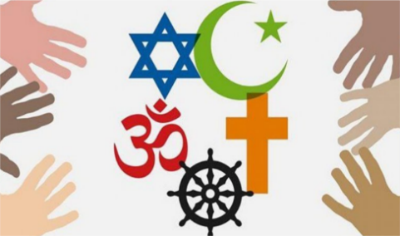

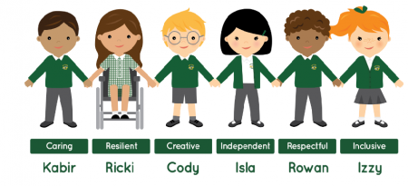

R.E in our Early Years

In Reception, children will encounter Christians and people of other faiths, as part of their growing sense of self, their own community and their place within it.

Children will discover religious and non-religious world views through special books, objects and celebrations/festivals throughout the year.

Our children are encouraged to develop their knowledge of beliefs and practices, exploring what different people believe and the difference it makes to how they live. The teaching of R.E. is designed to support positive attitudes and values and encourages children to reflect and relate learning to their own experience.

Key Vocabulary

Our pupils use ‘Knowledge Organisers’ to support their learning of key facts and vocabulary. They are encouraged to look back at their prior learning to consolidate what they have found out.



Remember?

These are key facts that children have learnt in R.E. throughout their time in school. These memory flashpoints are in the form of visual images on the interactive whiteboard, which the children are asked to name and connect to the corresponding faith/religion. Revisiting this learning at regular intervals helps us to store it in our long term memory.

**Practical discovery and**

**Role play**

**School outings**

Celebrating R.E at our school

**Fun and engaging activities**

**Special Visitors**

What do our children think about R.E

“Learning about Jesus and when he died”

“To be nice to people who are different”

“Learn to treat people fairly”

“Learning about muslims and things in a Mosque

**Learning through games**

Learning about important people like Mother Theresa”

“I like nature and exploring.”